**“Automatic Accident Alert System”**

**Er. Vinit Tirnagarwar.**

E&TC Department, AISSMS IOIT Pune, India.

***Abstract****— Vehicle accident is the paramount thread for the people's life which causes a serious wound or even dead. In India per day 821 road accident occurs due to human tragedy or due to driving rules violation. Road accident is threat to death person. After accident time is very critical parameter for saving life and it is very important to provide medical service as soon as possible. Sometime death occurs due to delay in emergency services, delay occur due to late alerts. We can save lot of time by making alert system fast and automatic, will result in life saving.*

*This paper presents a Automatic accident alert system for an automatic and fast accident alert./*In this system change of tilt angle with road surface is detected by using three axis accelerometer. As the tilted angle is more than permissible limit it will detect unusual state and send alert to nearby emergency contacts. Alert notification is send via SMS using GSM module. SMS will have the present GPS co-ordinates fetched from GPS module. Micro-controller based prototype is built and module communication is done by using USART protocol.*

*Present paper describes a model, which is done by using several software’s like proteus dip-trace and many more.A prototype of the proposed automatic accident alert system is built and tested to analyze the performance of the system.*

***Keywords: Universal Synchronous and Asynchronous Receive and Transmission (USART), Short Message Service (SMS), Global system for mobile (GSM),Global positioning system(GPS).***

**I. INTRODUCTION**

In recent years automotive company made so many upgrades in automotive. There are so many new techniques such as Antilock Breaking System (ABS), Adaptive Cruise Control (ACC), anti-Collision System (ACS) to avoid accidents and in spite of all this, such large number of accidents takes place. Hence the present system which give an idea about what can be done to provide medical help and other facilities after accident as soon as possible. Complete system partly divided into two major parts.

* Data acquisition.
* Module communication and alert sending.

1. In Proposed project, module uses GPS and GSM to get map co-ordinates and send alert. Real time angle deflection is measured with 3 axis accelerometer controller to get angle of deflection to surface. After obtaining three axis reading it is compared with threshold limit and if threshold is crossed it will send alert.
2. If deflection angle is crossed then controller fetch data from GPS Module and stores to its register. After this it will initialise GSM module and send message to programed numbers and will insert location to SMS.

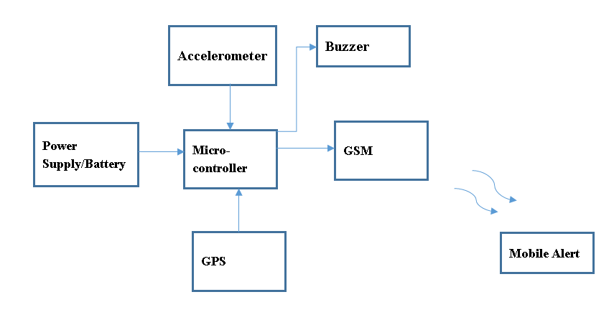**II. BLOCK DIAGRAM AND DESCRIPTION.**

**Fig 2.1: Block diagram of Model**

* Controller- P18f4550 is an advance 8bit microcontroller having eight analog to digital converter channels. All controlling action will be done by PIC micro controller.
* SIM 800C Module is a complete **Quad**-band GSM/GPRS solution in a SMT type, which can be embedded in the customer applications. USART protocol is used to give commands and sending alert.
* GPS- The Global Positioning System (**GPS**) is a space-based satellite navigation system that provides location and time information in all weather conditions, anywhere on or near the Earth where there is an unobstructed line of sight to four or more **GPS** satellites.

* Accelerometer - An accelerometer is a device that measures proper acceleration. Proper acceleration, being the acceleration of a body in its own instantaneous rest frame, is not the same as coordinate acceleration, being the acceleration in a fixed coordinate system.
* Buzzer-an electrical device that makes a buzzing noise and is used for signalling.
* Power Supply- 5v 1amp on board linear power supply is designed which will be directly power up from main and will be sufficient to run all components on the board.

**III. CIRCUIT CONFIGURATION**

**SOFTWARE INFORMATION**

* Simulation software

Proteus V2.0

developed by lab centre electronics

released in 1988,England.

thousands of electronics component library provided

also support PCB layout Designing.

* PCB Design Software

DipTrace 3.2.1

deeloped by "Novarm Ltd."

CAD based software for schematic design.

auto routing and 3D PCB Preview provided.

**Fig 3.1:** Simulation Prototyping.

[A]: Model Simulation.

Basic system module is designed on proteus simulation environment for basic module and programming testing, software description are explained as above in same section.

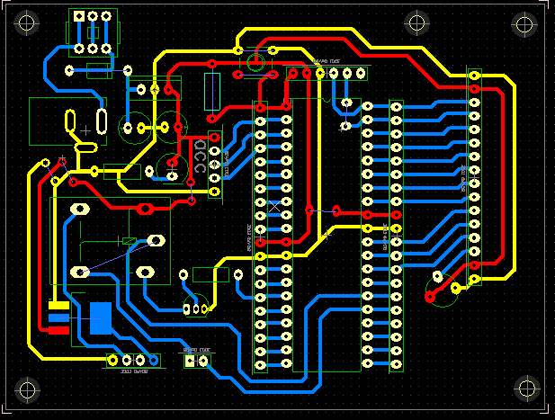

**Fig 3.2.1:** PCB design of module

[B] Model designing.

Hardware module is designed on Dip trace PCB designing software, software description are explained as above in same section.

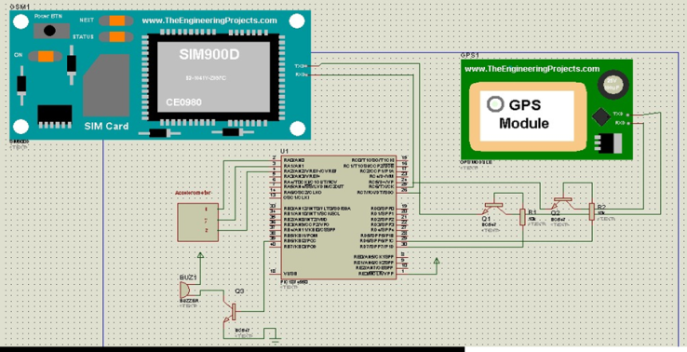

**IV. PROTOTYPE MODULE.**

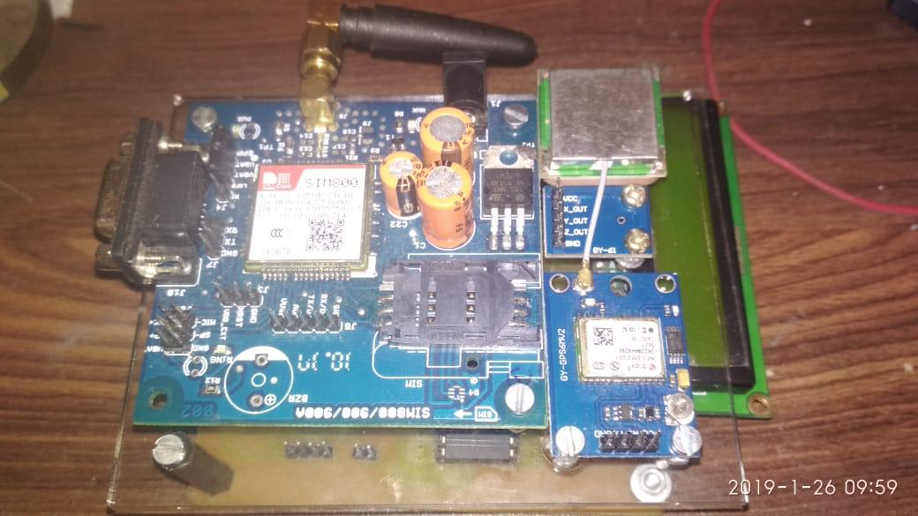

**Fig 3.3: Prototype Module**

Prototype Module is built after circuit simulation PCB designing is done as shown in fig 3.2.1 by using dip-trace software and proteus simulation. Prototype module important parts/components are explained as below

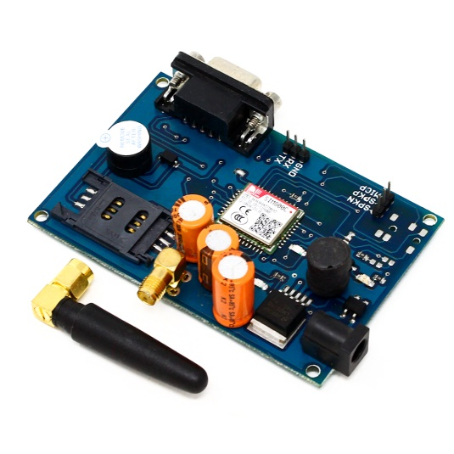

**Fig 3.3.1: GSM Module.**

Module 1: SIM800 GSM Module.

GSM module works on certain commands which are given by another node/micro-controller. The main purpose of GSM module is to send SMS on pre-programmed numbers with GPS co-ordinates. Commands are given via usart protocol.

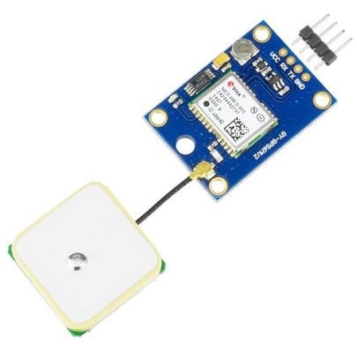

**Fig 3.3.2: GPS Module.**

Module 2: GPS Module.

Neo 6M GPS have so many in built features it can connect up to 12 satellites and it fetches location with 6Meter range. It continuously transmits data with USART protocol. Its huge data with multiple information data sorted by micro-controller.

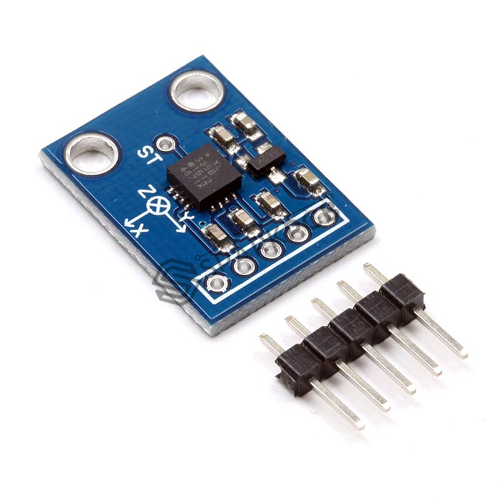

**Fig 3.3.3: Accelerometer..**

Module 3: **:** Accelerometer

It is three axis accelerometer which gives continues update of movements in three axis by varying analog voltage at the output pin of module.

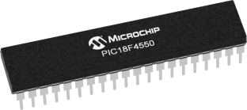

**Fig 3.3.4: PIC Micro-Controller.**

Module 3: Controller.

PIC micro-controller is a RISC based 8 bit micro-controller. Controller is responsible for data separation and giving commands to GSM module.

**V. ANDROID ALERT**

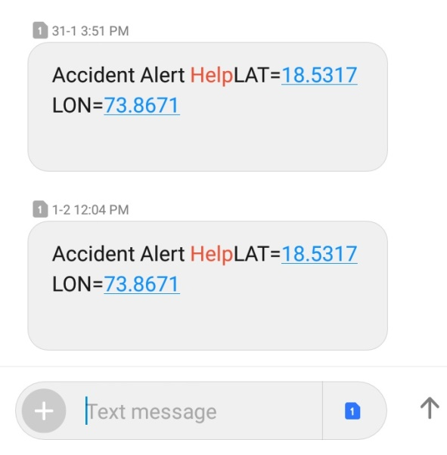

Fig 3.4: Android alert.

Android alert came via SMS. SMS is sent by GSM module of the system. SMS contain GPS module co-ordinates in the form of Latitude and Longitude as shown in the fig.3.4. when this co-ordinates are copied into any software map it will show the exact location of the device.

**VI. EXPERIMENTAL RESULT**

Following results are obtained after experimentation of prototype model.

The Accident Alert System is aims at providing an excellent notification system in case of accidents and emergencies. The project targets to bring a fall in the number of accident fatalities around the world. A large number of fatalities occur in such cases due to late access to medical help and first aid. This scenario can be changed by the use of an efficient notification system.  
In case of occurrence of an accident, the vibration sensor will detect the collision and send the signal to the microcontroller. The microcontroller acknowledges the signal and starts the execution of the delay program. If the accident isn't bad enough, then the driver can press a button and stop further activities of the circuit. protection enabled successfully.

**VII. CONCLUSION**

In this paper, we have shown that road accident can be detected efficiently by using some particular parameters. Our proposed approach capable of deciding whether a situation is an accident or not and if so, then immediately traces nearest police station as well as hospital and send emergency alert message for help. Besides, we have demonstrated the reduction of false alarm in a greater extent compared to other previous works. Though the system requires a continuous network connection, but this it is very much cost effective and can be applied significantly in the practical world.

**VIII. REFERENCES**

[1] Adnan Bin Faiz,Ahmed Imteaj ,Mahfuzulhoq Chowdhury “Smart Vehicle Accident Detection and Alarming System Using a Smartphone”1st International Conference on Computer & Information Engineering, 26-27 November, 2015 Organizer: Dept. of CSE, Rajshahi University of Engineering & Technology, Rajshahi, Bangladesh

[2] Bankar Sanket Anil, Kale Aniket Vilas, Prof. S. R. Jagtap “Intelligent System for Vehicular Accident Detection and Notification”**International Conference on Communication and Signal Processing, April 3-5,2014, India**

[3] Bannaravuri Amrutha Valli,Pratibha jonnala. “Vechile Positing system with accident detection using Accelerometer sensor and android technology.”,**IEEE international conference on technology innovations in ICT for agriculture and rural development**

[4] Highlights of 2009 Motor Vehicle crashes, Tramc Safety Facts, Research Notes, NHTSA (National Highway traffic Safety Administration) [Online], Accessed on 16 October 2011.